1. (20%) The definition of the Legendre polynomial is as follow: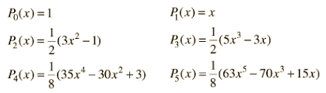

Please drew five curves P0(x) ~ P5(x) as the figure 1, x has a value between [-1, 1] with the step 0.004.

1. Please draw these five curves on the same figure, remember to use the legend command to identify each curve.
2. Please get the graphic handle of P4(x), and use it to change the (i) color, (ii) linewidth, (iii) line type of P3(x).

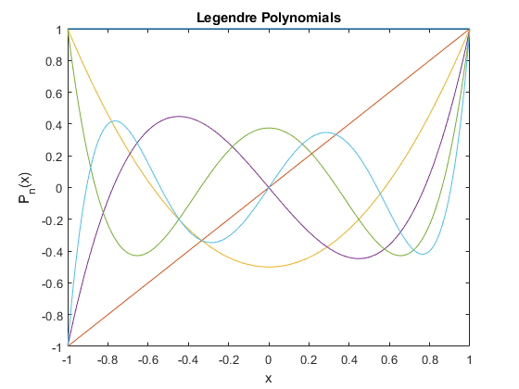

Fig 1.

1. (30%) Use the MATLAB command to draw a surface plot of the following functions:



Where x is equally divided into 21 points between [-2, 2], and y is equally divided into 21 points between [-1, 1], so this surface has 21*21=441 points.

1. Use the ‘meshgrid’ command to build up a meshgrid in the x-y plane.
2. Plot the surface and the mesh of the z(x,y).
3. To rotate your surface plot at fix elevation angle at pi/4 degree, and variable azimuth angles between [-pi, +pi] with the step of pi/10.
4. you can use the gradient function to estimate the derivatives and draw the gradient by using common ‘quiver’ in the same figure with the contour plot, adding the color bar of the contour.
5. Explain the physical meaning of gradient field.



Fig 2.

1. (25%) (a) Create a structure array that contains the following information fields concerning the road bridges in a town: bridge location, maximum load (tons), year built, year due for maintenance. Then enter the following data into the array:

|  |  |  |  |
| --- | --- | --- | --- |
| **Location** | **Max. load** | **Year built** | **Due for maintenance** |
| Smith St. | 80 | 1928 | 2011 |
| Hope Ave. | 90 | 1950 | 2013 |
| Clark St. | 85 | 1933 | 2012 |
| North Rd. | 100 | 1960 | 2012 |

(b) Edit the structure array to change the maintenance data for the Clark St. bridge from 2012 to 2018.

(c) get the values of the year due for maintenance of every bridges.

(d) ranking the years of (c) and listing it by the bridge location.

That is: Smith St. 🡪 North Rd. 🡪Hope Ave 🡪 Clark St.

1. (25%) Use the MATLAB command [C = readcell(filename)](https://ww2.mathworks.cn/help/matlab/ref/readcell.html#d124e1188084) to read the test_score1.xls file (in the i-learn) and store the score in a cell matrix then calculate the average of the mid-term and final scores, and plot the distribution of the mid-term score with value between [60 100] with the step 5.

Numbers of student with scores in between 60 to 64

